SPRINT – 2

|  |  |
| --- | --- |
| **Date** | **15-11-2022** |
| **Team ID** | **PNT2022TMID36755** |
| **Project Name** | **Project - IOT based smart crop**  **protection for agriculture** |
| **Maximum Marks** | **20 Marks** |

**Steps:**

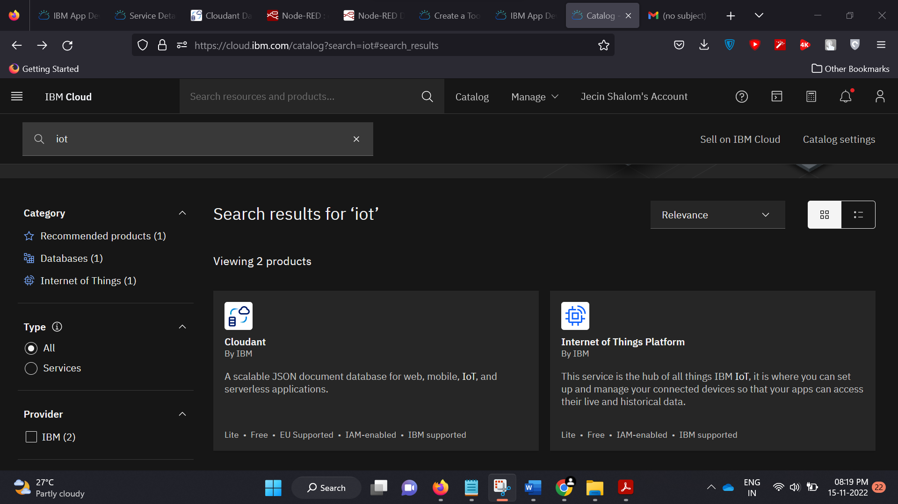

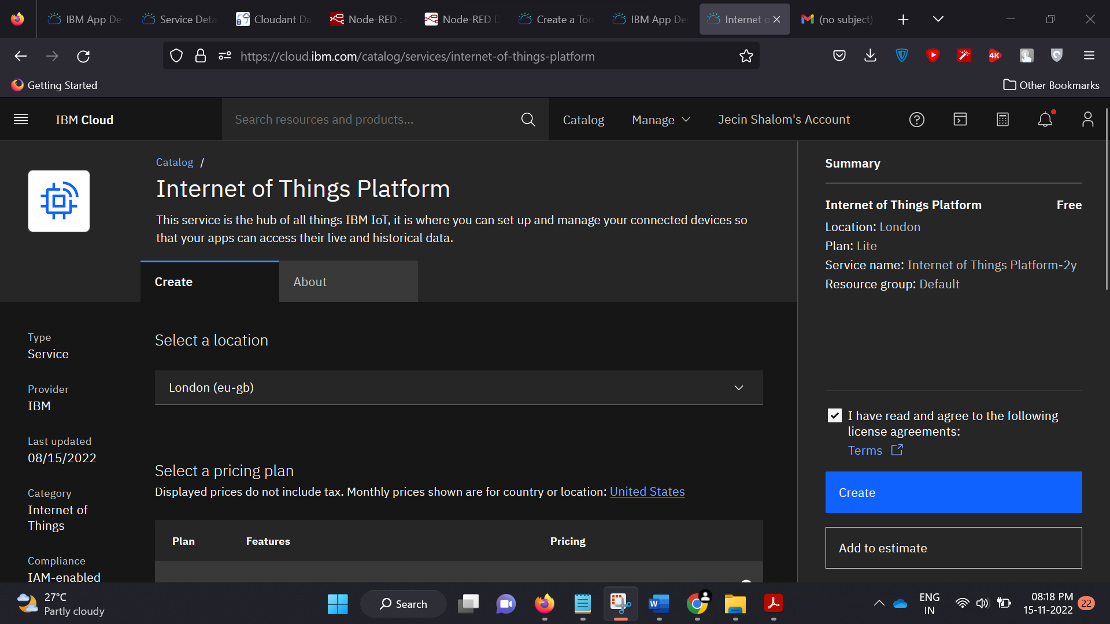

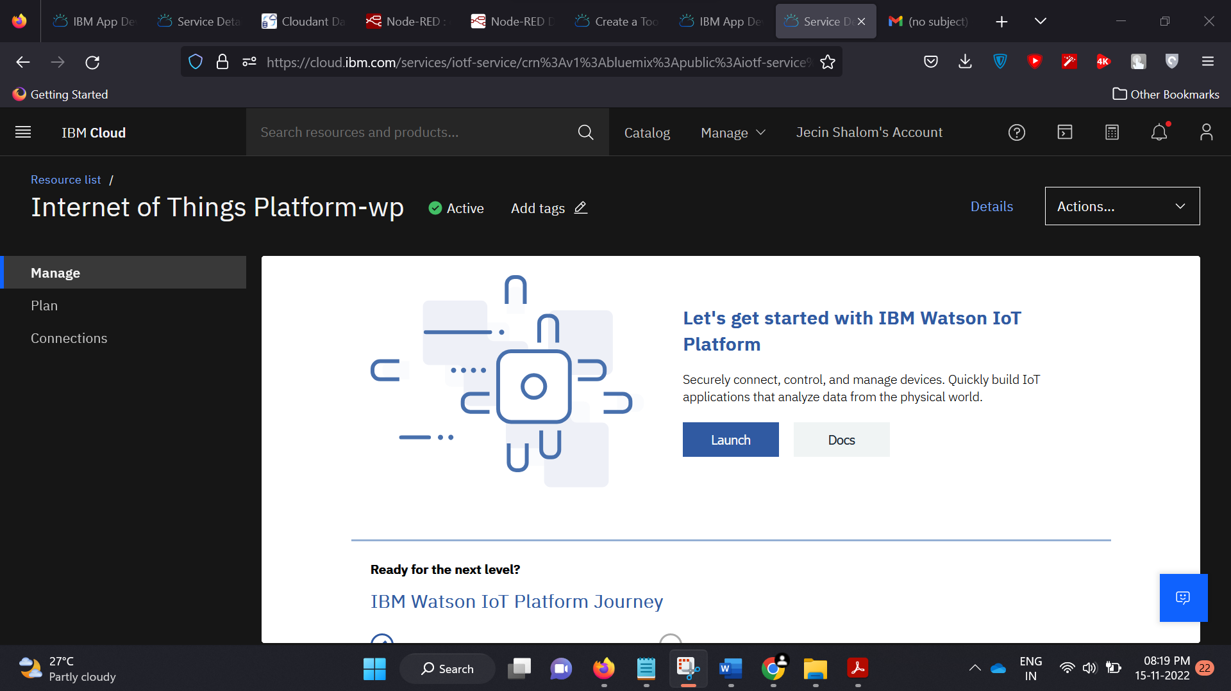

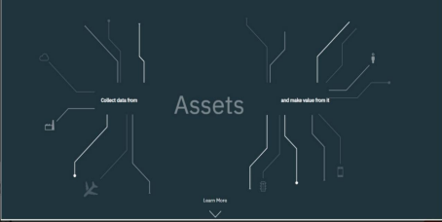

DEVICE CREDENTIALS INFORMATION :

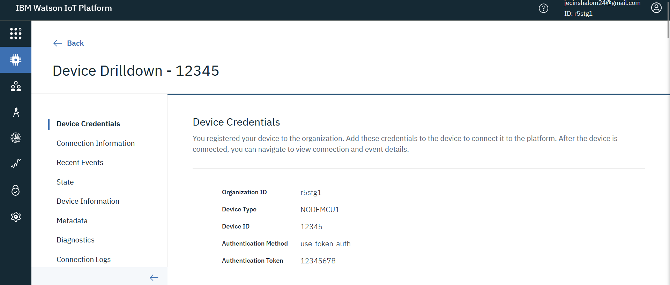

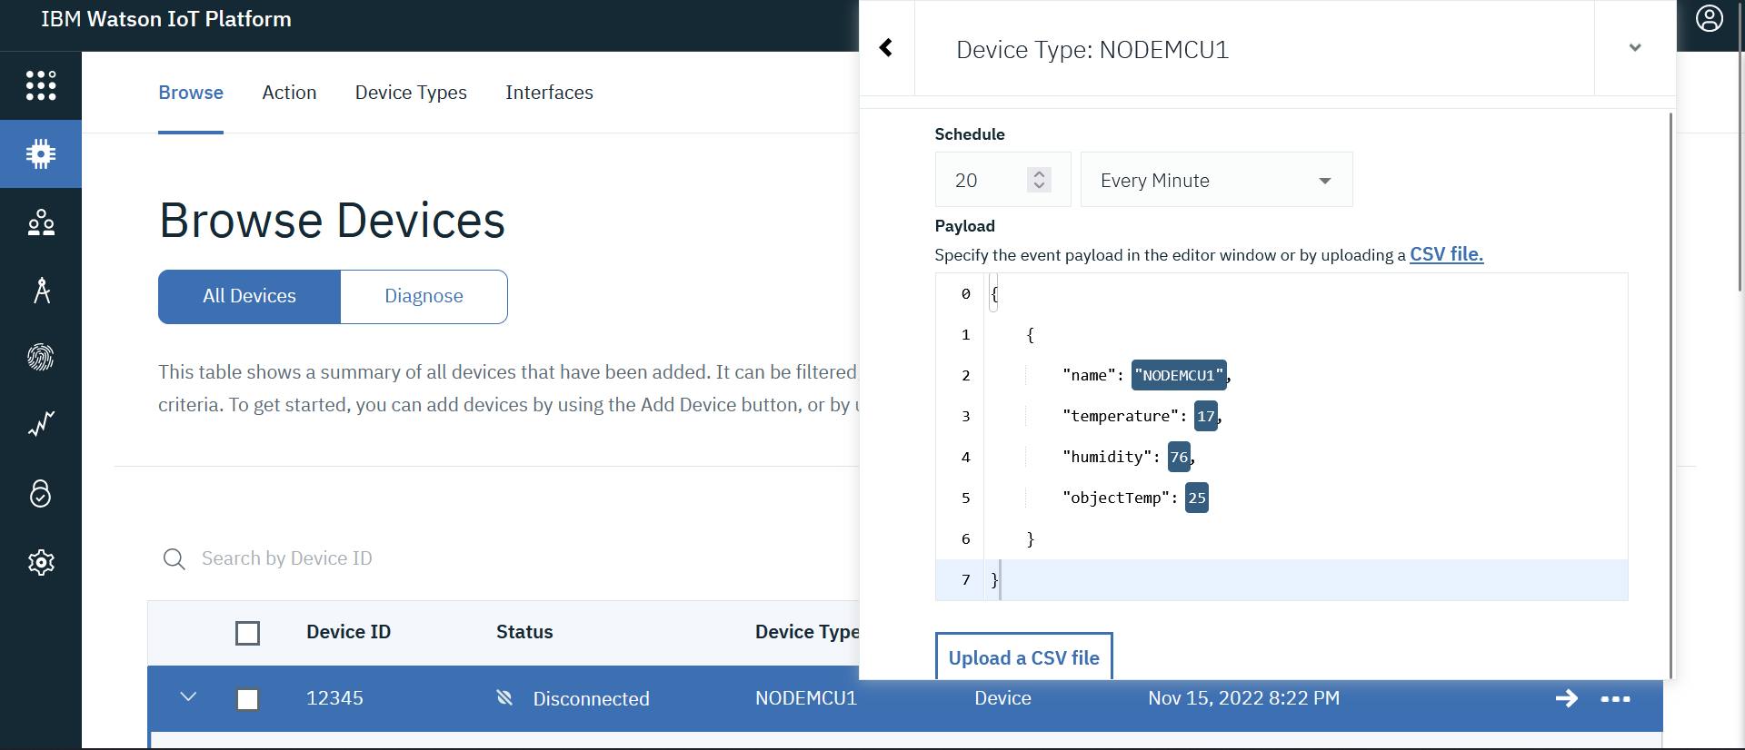

OUTPUT :

